Transgender student lets secret out
By Chris PurdyThe Canadian Press
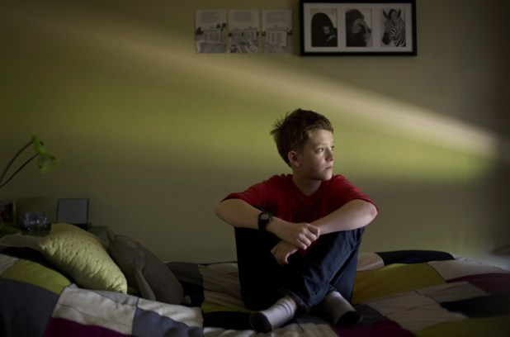
EDMONTON – When 11-year-old Wren Kauffman goes back to school this week, he won’t be hiding the fact that he’s actually a girl. Teachers, friends and other students at his Edmonton school know the truth — that he’s a girl on the outside but feels like a boy on the inside. And that’s why, even at such a young age, he has chosen to live in the world as the opposite sex, and not keep it a secret. “If you’re not yourself, then it kind of gets sad and depressing,” says the freckle-faced kid with short-cropped hair. “I’m glad that I told everybody.”

More students these days are not just coming out in school as gay but also as transgender or transsexual, and they’re doing it at younger ages, says Kris Wells, a researcher with the Institute for Sexual Minority Studies and Services at the University of Alberta.

Some studies shows six out of 1,000 students experience transgenderism. About one out of 170 teachers are transgender. Wells says his office gets calls and emails from parents and schools across the country at least once a day asking for advice. A few years ago, he helped a child swap sex roles while in Grade 2 at a Catholic school in rural Alberta.

Some students and their families choose a more secretive approach, switching schools or even moving to other provinces, so they can start fresh, he says. Others transition over the summer and return to school in the fall identifying with their new sex.

Brave students, like Wren, proudly announce who they used to be — and who they are now.

Wren, born Wrenna, says he doesn’t remember a time when he didn’t feel like a boy.

Growing up, he hated wearing dresses. He liked Spiderman and dressed up as comic book hero The Thing one Halloween. When he was five, he had his mom take him to a hairdresser to cut off his long, brown locks. He wanted to look like Zac Efron from the movie “High School Musical.” Wendy Kauffman says she and her husband, Greg, knew their daughter was different. She would often ask: “When do I get to be a boy?” And she pleaded to be born again in order to come out right.

They thought it was a phase. Then they thought their child might be gay. But as Wren got bigger, so did the sadness and frustration.
Kauffman says it finally hit home when Wren was about nine and Kauffman was tucking her six-year-old child, Avy, into bed one night. “She said to me, ‘You know, Mom, Wren is a boy and he told me to tell you.’” Kauffman says she got a bit defensive. “‘I said, ‘Well, I know Wren wants to be a boy.’ “Avy said, ‘No, Mom, he REALLY wants to be a boy.’”
Kauffman, tears welling up in her eyes, says it was a pivotal moment. Her youngest child had seen it all so clearly and, now, she did too.

Kauffman later told Wren: “I love you whether you’re a boy or a girl and I understand now. And we’ll figure out how we can help you. And we’ll do it together.”
Wren and his family say they have gone public and been in the media this year so that others going through the same situation know they’re not alone. Kauffman hopes other parents realize how important it is to really listen to their children. Wren wants other kids to know it’s OK to be who they are. Kauffman says she and her husband initially consulted with Wells about Wren’s transition and he first started living life at home as a boy. After about a year, they were ready to tell his school.

Wren was in Grade 5 at Belgravia School, where students occasionally gathered in sharing circles to talk about life events such as the separation of parents or a family death. He took his turn to tell his classmates that he was now living his life as a boy. Some kids had questions, but they were all supportive, Kauffman says. The following year, Wren transferred to Victoria School of the Arts. At first, he was private about his actual sex, but after a few months he told friends and shared his story with his class.

There are a couple of older transgender students at the school, but Wren is by far the youngest. He says it hasn’t been a big deal. He uses the boys’ washroom “which, by the way, is much grosser than the girls’ bathroom.” He also changes in a stall in the boys’ gym locker room.

Wren has started monthly drug injections to pause female puberty. When he’s about 16, he’ll decide whether he wants to start injecting male hormones. At 18, he’ll be legally old enough to have sex reassignment surgery. Wren says he’s not sure yet if he wants to take that final step. He’s just excited to start Grade 7. His school is part of the Edmonton Public School Board which, in 2011, became the first in the province to develop a policy to protect gay, lesbian and transgender students and staff from discrimination based on sexual orientation.

Wren says he hasn’t been subjected to any harassment. Just some teasing when he first came out — one student winked and called him “Mr. Kauffman.” A couple of others asked for proof that he was actually a girl, but Wren laughed it off and told them he wasn’t prepared to pull down his pants. Wren says he knows it won’t always be this easy and he’s prepared for the possibility that he may be bullied later in life. “People tease me right now and I can handle it. The way that I like to look at it is that they’re just practice for the real jerks in life. “And, besides, if they say something to me, then they don’t have to be part of my life … I don’t think I need people who don’t like me.”

